Japanese life in Latin America before World War II

The political situation of the Japanese in Latin America was symbiotic with that of the economic situation of both countries. One of the main reasons that such a large number of Japanese migrated to Latin American countries was because of the economic situation of Japan after World War I. Likewise the economic boom of Latin America mixed with its inability to recruit migrant workers from Europe, fostered the importation of Japanese business and workers.
When the economic situation reversed, Latin American countries fell into a depression and sacrificed its Japanese population in order to attain the support of neighboring countries by way of international loans from the United States.

- Japanese in economic crisis after World War I
  - Encouraged its citizens to work overseas
    - Overseas Emigration Societies Act of 1927
  - United States Immigration Act of 1924 closed off borders to most Japanese workers
    - Japanese already in Latin America welcomed other Japanese
    - Japanese government would pay expenses for outsourced workers
    - 1934 Japanese government paid a subsidy of 1300-1400 yen per family
      - fostered women to immigrate and create families
  - Japanese in Latin American countries became successful in various business ventures
    - Used money from businesses to develop and grow independent from the Latin culture as well as boost Japan economy

  - 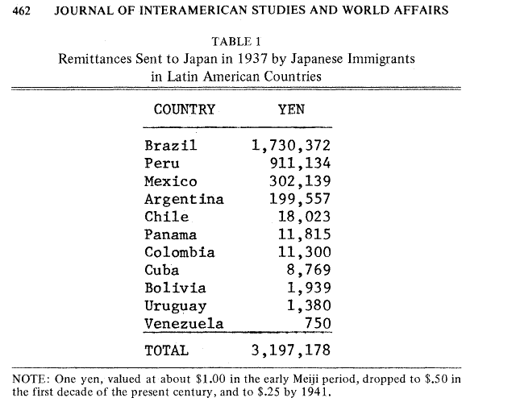
      - Highly regarded as individuals
      - Group exclusiveness aroused suspicion
- 1898 Peru experiencing economic boom.
  - Encouraged importation of jobs from Europe
    - Italy encouraged citizens not to go
  - Japan needed to outsource workers
  - Peru accepted them
    - 6 month – 3 year terms
    - 60% of initial workers married into the culture
- Peru economy begins to decline
  - Unemployment rises
  - Local population upset at success of Japanese business
  - Riots
  - Economic ad social pressure causes Peruvian Government to deport Latin Japanese to United States
    - Unofficially to get loans from United States for help with Peruvian economy

